1. Website Specifications

Website Objective
The objective of this website is to promote my video production services and attract people who want their special moments captured in a cinematic and professional way. My goal is to create high-quality, clear and emotional videos that feel like movie scenes, similar to the visual quality seen in Netflix productions. I want my videos to capture real moments and allow viewers to feel a deeper connection to the memories being recorded.

Website Goals
The goal of the website is to help me grow my video production business and reach clients who need professional filming services. The website will promote services such as wedding videography, birthday parties, commercial videos, music videos and other events. The aim is not just to record events but to create cinematic content that people can emotionally connect with.

Target Audience
The target audience includes couples, food companies, musicians, actors and event organisers who need professional video coverage. Most users will be between 18 and 45 years old and will access the website using smartphones, tablets or computers.

Type of Website
This will be a business service website that promotes video production services, showcases video content and allows potential clients to contact the business.

2. Information Design & Taxonomy

The website will be designed with a simple and clear navigation structure so that visitors can easily find information about the services offered. The main pages will include Home, About, Services, Contact and Feedback. The Home page will introduce the brand and its cinematic style. The Services page will describe the different types of events covered such as weddings, corporate events, concerts and music videos. The Gallery page will show examples of previous work.

Site Map
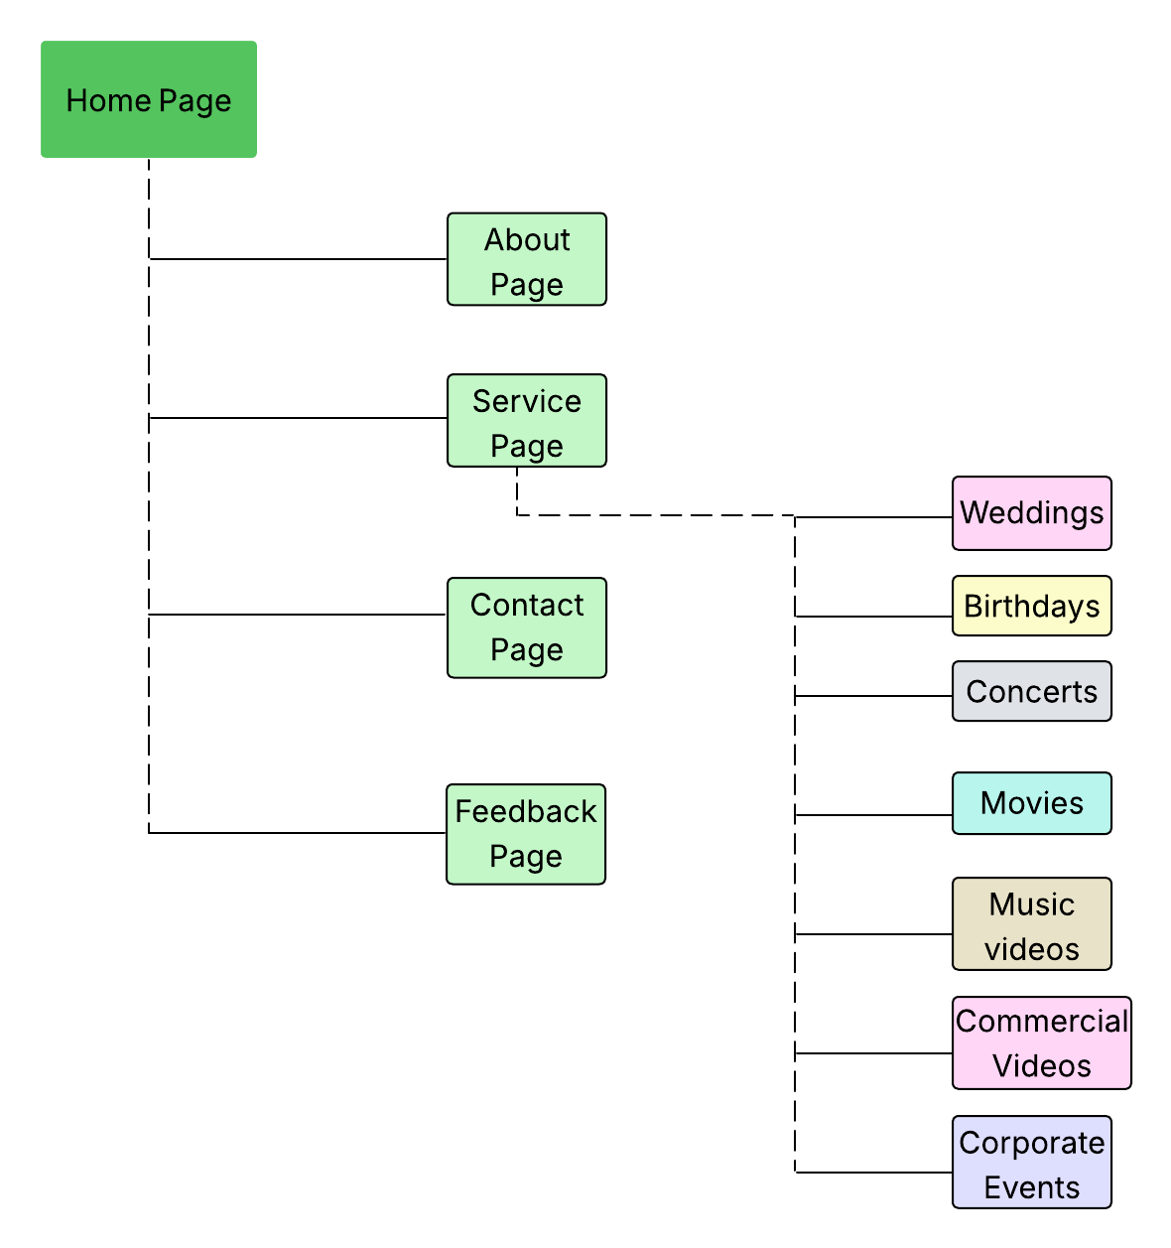

3. Technical Brief

The website will be developed using HTML5 for the structure of the pages and CSS3 for styling and layout. JavaScript will be used to add basic interactivity. The Bootstrap framework will help make the website responsive, so it works well on mobile phones, tablets and computers.

The website will be developed using Visual Studio Code. The project will be stored in a GitHub repository, and the final website will be published online using GitHub Pages.

